Brighton Harley-Davidson Riding Academy® Cancellation Policy & Program Requirements
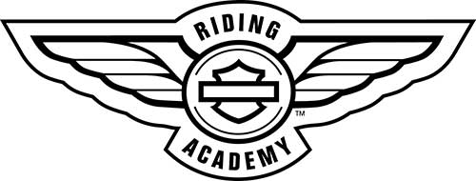

Riding Academy® New Rider Course Cancellation Policy and Program Requirements
Cancellation and Refund Policy:
For any reason a customer can cancel their reservation up to two weeks prior to their scheduled course. If you cancel after the two week deadline for any reason, a refund is not offered. However, you will be eligible for our “stand-by list” (see below for details)
Program Requirements and Rules:
- Each Class has a limit of 10 students.
- After start of class, no student substitutions allowed.
- Each class consists of 2 nights of classroom and 2 days of range to be completed. consecutively and there is no date splitting.
- Riding Academy® Coaches reserve the right to counseled out unsafe students they deem dangerous to themselves, other students, equipment or instructors. If counseled out, no refund will be granted.
- No refunds or make up dates are offered to those who leave the class of their own free will without written consent from your instructors.
Stand-by List Policy:
If you had to cancel your reservation after the two week cancellation policy you are going to be put on the stand by-list. Students on the stand-by list will be notified when a student cancels their reservation within the "two week no refund period". The notice is usually short but it will be offered to the stand-by student in order of cancellation and is first come first serve.
Payment Policy:
Payment is due at the time of registration either on-line, call in or in store.

