YUMA BABY!

Yuma Baby started out as a Cracker Barrel run to Yuma, and has evolved into the 2 night adults-only party we know and love today! Come ride with, party, hang out, and get to better know your fellow HOGs out to Yuma, through the gorgeous mountains, desert landscape and finally to La Fuente Inn and Suites! Come meet your next best friend, as many have before you!

Dates: Yuma Baby I: 4/24 to 4/26 Yuma Baby Too: 10/23 to 10/25 Both Friday to Sunday

Location: La Fuente Inn and Suites, 1513 E 16th St, Yuma, AZ 85365
Reservations: (928) 329-1814 (San Diego HOG has a block of rooms, ask for the rate!)

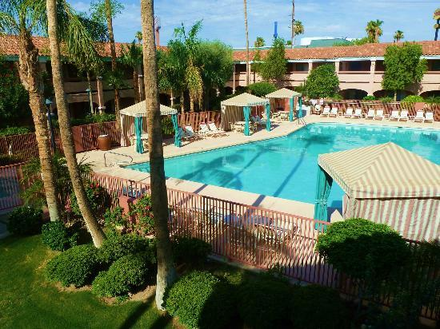
There is an organized Chapter Ride out to each Yuma Baby, watch the website, FB, and Blast for info!

Planned fun:

Friday:
Sell bug stickers for the ride out! Bring cash, small bills!
Fun ride out to Yuma, stopping at Famous Dave’s in El Centro for lunch
Arrive around 230-3pm for check-in, Happy Hour is 5-7! Some drink, some don’t!
Hang out poolside with your HOG Family!
After an hour or two, groups ride over to Go Karting at the local Fun Center with Clarke!
Order in or walk to food, usually a group hits Cracker Barrel in keeping w tradition

Saturday Day:
Ride to Lake Martinez/Suspension Bridge
Lunch Destination, sometimes Lute’s, or Downtown Yuma.
Occasional local Motorcycle/Car Shows the last few times we’ve visited!
Hang at the pool, many do...strongly suggest to bring pool toys and water guns!!!
Yuma Territorial Prison is an awesome historic site to visit!

Saturday Afternoon/Evening:
SDHOG hangs poolside!
SDHOG BBQ’s!!! Carne asada, pollo asada, and more with ALL the fixin’s! $10/person
Chapter picture from above!
Karaoke contest
Game playing and for Yuma Baby Too: some sort of costume/decorating contest around Halloween!

Sunday Morning:
Everyone rides homes on their own schedule, no group ride home.
If you’d like to ride home with someone or a group, chat em up!

2020 Yuma Babies: First Yuma Baby of the Year is SDHOG and friends only (keeping it family to bond us all together), Second Yuma Baby of the Year is for all Chapters to join in the fun!

